Regressions
The table below shows images of models from some tests that have visual regressions. Tests are performed using default resource files.
For comparison, Solid Works images of the same models are given.
Disabling AddNaturalBound option of ShapeHealing corrects the situation.
OCCT | SW | Code
test de iges_1 G8
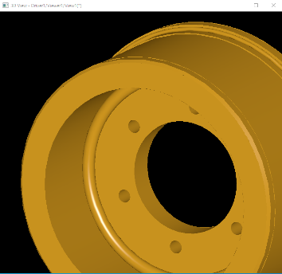 | 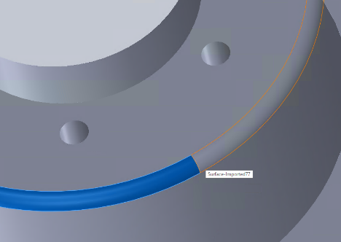 | IGESGeom_TrimmedSurface  Surface to be trimmed : 41:D81 Type:120 Form:0 Class:SurfaceOfRevolution  Boundary type : 1  Outer Boundary : 56:D111 Type:142 Form:0 Class:CurveOnSurface  Inner Boundaries : (Empty List)
test de iges_1 J9
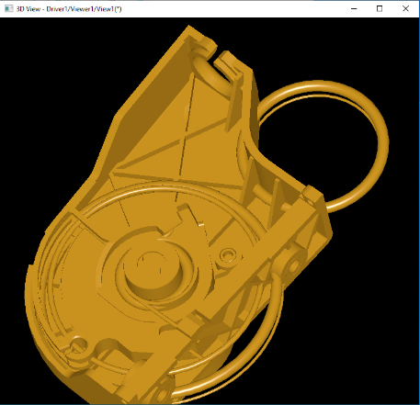 | 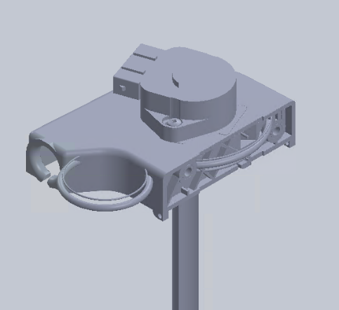 | IGESSolid_Face  Surface : 12402:D24803 Type:198 Form:1 Class:ToroidalSurface  Outer loop is not present  Loops : (Count : 1) :  [ 1]:10404:D20807 Type:508 Form:1 Class:Loop
test de step_1 E1
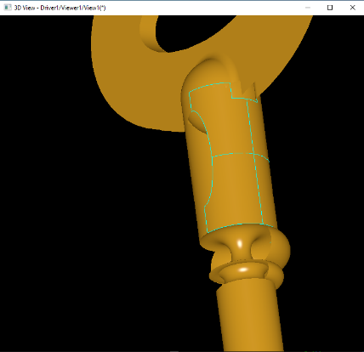 | 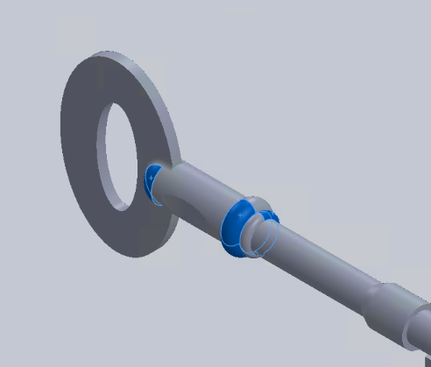 | 3106:#3570 = TOROIDAL_SURFACE('',3105:#3569,0.15,0.100285503404);  3142:#3615 = CURVE_BOUNDED_SURFACE('',3106:#3570,(5981:#3614),.F.);  5981:#3614 = OUTER_BOUNDARY_CURVE('',(5974:#3607,5976:#3609,5977:#3610,5978:#3611,5980:#3613),.F.);
test de step_1 E2
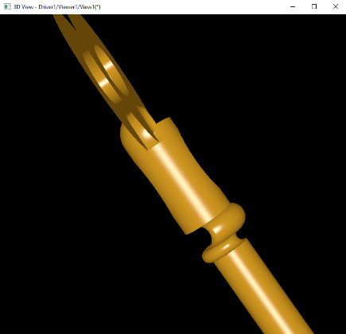 | 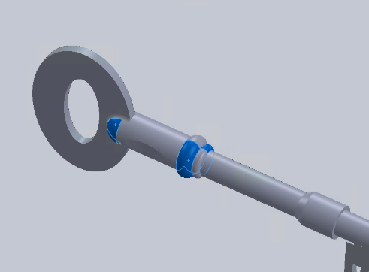 | 3110:#3574 = TOROIDAL_SURFACE('',3109:#3573,0.15,0.100285503404);  3146:#3619 = CURVE_BOUNDED_SURFACE('',3110:#3574,(5961:#3618),.F.);  5961:#3618 = OUTER_BOUNDARY_CURVE('',(5954:#3611,5956:#3613,5957:#3614,5958:#3615,5960:#3617),.F.);
test de step_1 G9
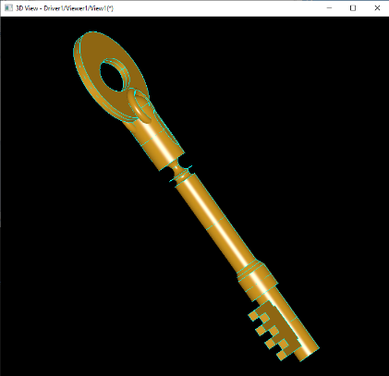 | 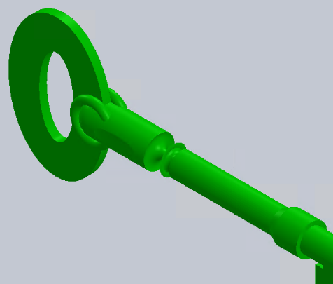 | #1717 = TOROIDAL_SURFACE('#1717',#1716,0.22912878475,5.E-02);  #1750 = BOUNDARY_CURVE('#1750',(#1725,#1733,#1741,#1749),.F.);  #1751 = CURVE_BOUNDED_SURFACE('#1751',#1717,(#1750),.F.);
test de step_2 B3
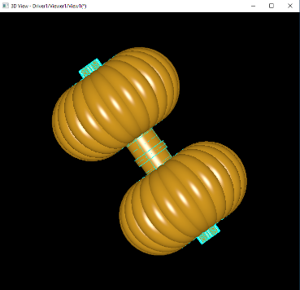 | 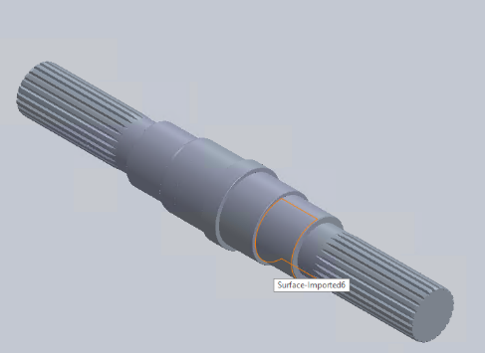 | 5147:#7074 = TOROIDAL_SURFACE('',5146:#7073,94.19517153949,34.2);  5148:#7080 = CURVE_BOUNDED_SURFACE('',5147:#7074,(9544:#7079),.F.);  9544:#7079 = OUTER_BOUNDARY_CURVE('',(9540:#7075,9541:#7076,9542:#7077,9543:#7078),.F.);
test de step_2 Q5
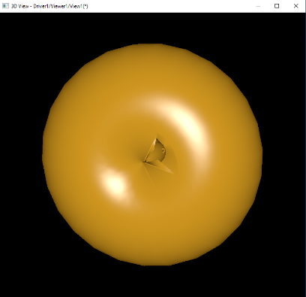 | 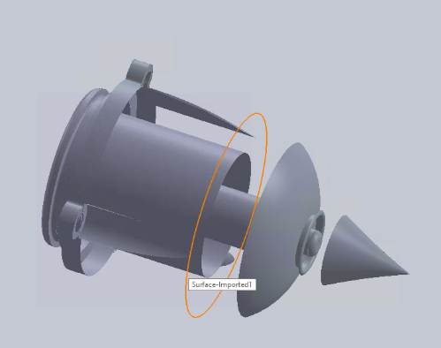 | #4355 = TOROIDAL_SURFACE('',#4356,0.130121241205,0.159999996424);  #5841 = ADVANCED_FACE('',(#5842),#4355,.F.);  #5842 = FACE_BOUND('',#5843,.F.);
test de step_2 Q6
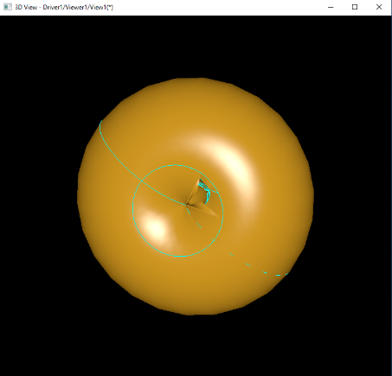 | 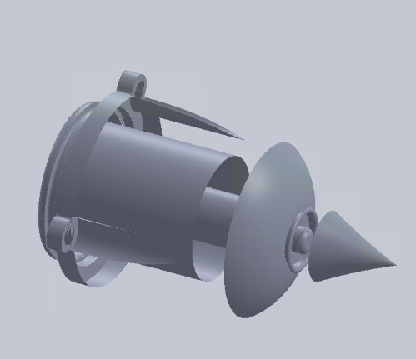 | #4355 = TOROIDAL_SURFACE('',#4356,0.130121241205,0.159999996424);  #5841 = ADVANCED_FACE('',(#5842),#4355,.F.);  #5842 = FACE_BOUND('',#5843,.F.);
test de step_3 B9
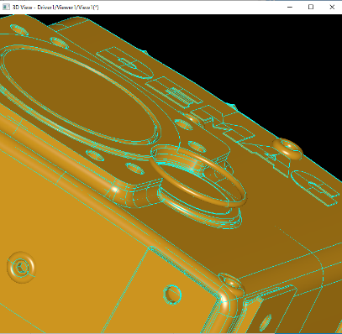 | 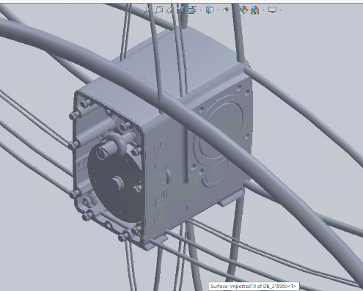 | 24957:#31197 = TOROIDAL_SURFACE('',24956:#31196,43.70917206496,2.5);  24958:#31205 = CURVE_BOUNDED_SURFACE('',24957:#31197,(78740:#31204),.F.);  78740:#31204 = OUTER_BOUNDARY_CURVE('',(78734:#31198,78735:#31199,78736:#31200,78737:#31201,78738:#31202,78739:#31203),.F.);
test de step_3 C8
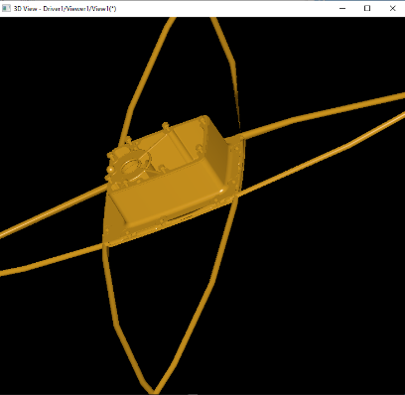 | 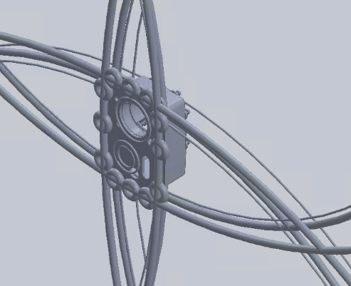 | 8638:#11006 = TOROIDAL_SURFACE('',8637:#11005,1.692841838119E+03,7.);  8639:#11020 = CURVE_BOUNDED_SURFACE('',8638:#11006,(23826:#11019),.F.);  23826:#11019 = OUTER_BOUNDARY_CURVE('',(23814:#11007,23815:#11008,  23816:#11009,23817:#11010,23818:#11011,23819:#11012,23820:#11013,  23821:#11014,23822:#11015,23823:#11016,23824:#11017,23825:#11018),.F.);
test de step_3 E4
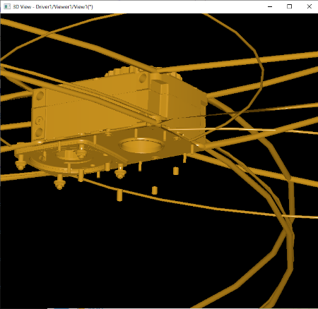 | 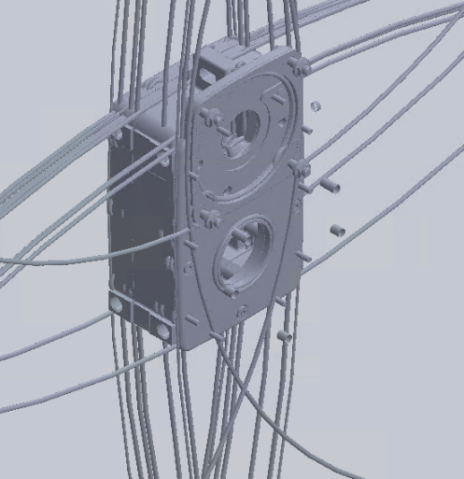 | 71086:#97513 = TOROIDAL_SURFACE('',71085:#97512,5.8,0.8);  71087:#97519 = CURVE_BOUNDED_SURFACE('',71086:#97513,(100792:#97518),.F.);  100792:#97518 = OUTER_BOUNDARY_CURVE('',(100788:#97514,100789:#97515,100790:#97516,100791:#97517),.F.);

The table below shows images of models from some tests that have regressions or improvements. Tests are performed using default resource files.

OCCT | SW | Comment
test de iges_1 J6
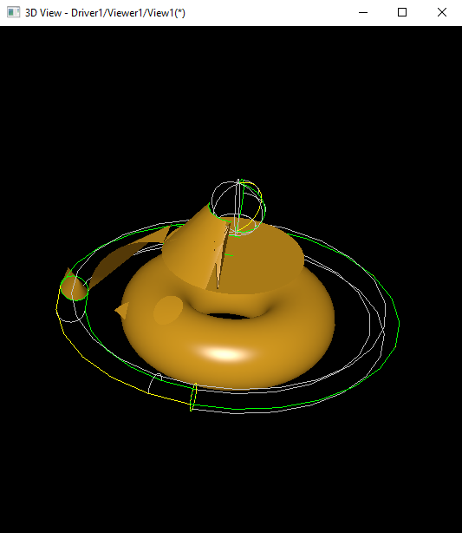 | 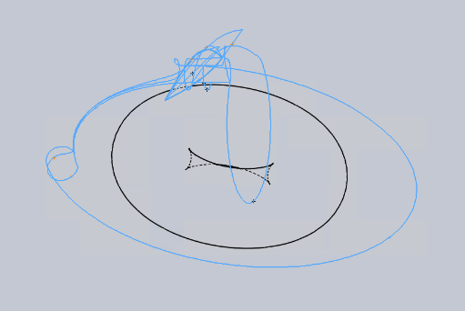 | The model for this test has a bad definition. The way out to make the test valid is to correct the numbers.
test bugs step bug24055
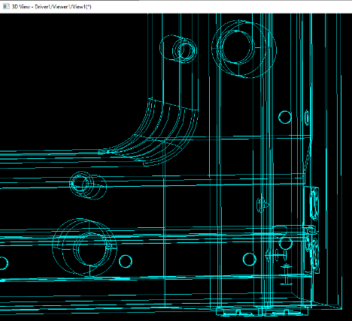 | 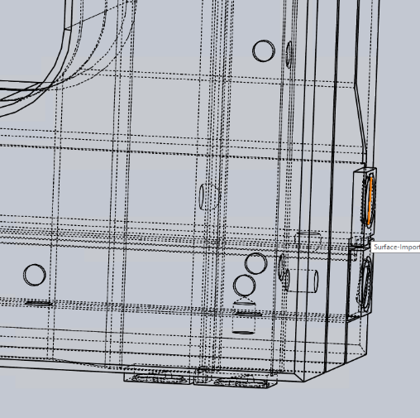 | The model for this test has a visual regression. The regression is that a spherical hole was formed in the part instead of a spherical bulge on the part (master branch). These faces are given as single INNER wire on spherical surface in STEP file. Model in Solid Works has the same image.  It looks like improvement.
test sat doc_5 H6
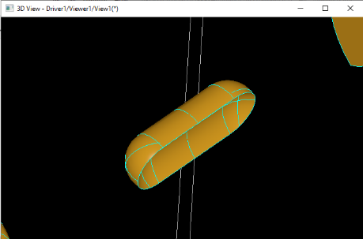 | 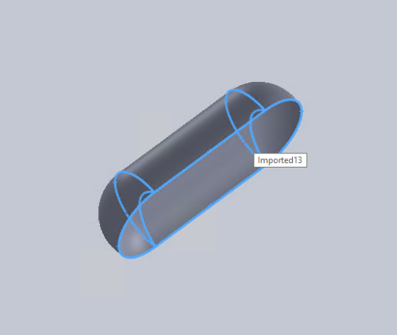 | The model for this test has a visual regression. The regression is that a left spherical end of the part looks like the right end of the part. Model in Solid Works has the same image. On the master branch it’s inverted, and the closed shell is not formed.  It looks like improvement.

