Regressions
OCCT | SW | Code
test de iges_1 G8
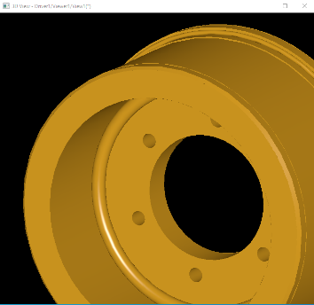 | 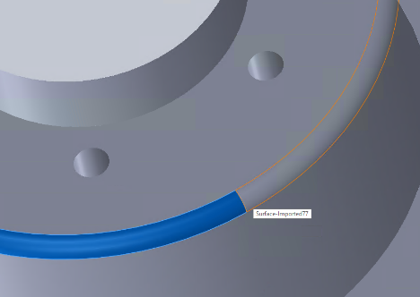 | IGESGeom_TrimmedSurface  Surface to be trimmed : 41:D81 Type:120 Form:0 Class:SurfaceOfRevolution  Boundary type : 1  Outer Boundary : 56:D111 Type:142 Form:0 Class:CurveOnSurface  Inner Boundaries : (Empty List)
test de iges_1 J9
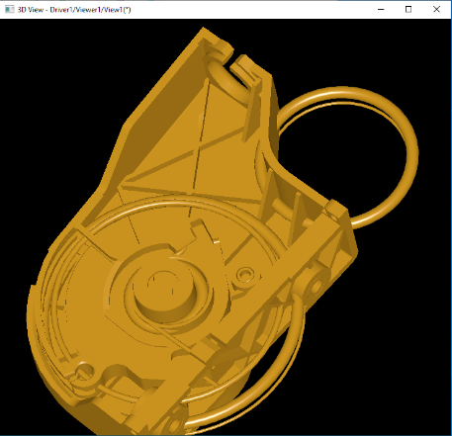 | 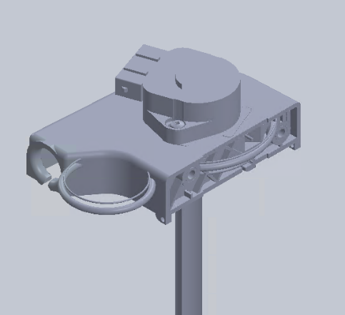 | IGESSolid_Face  Surface : 12402:D24803 Type:198 Form:1 Class:ToroidalSurface  Outer loop is not present  Loops : (Count : 1) :  [ 1]:10404:D20807 Type:508 Form:1 Class:Loop
test de step_1 E1
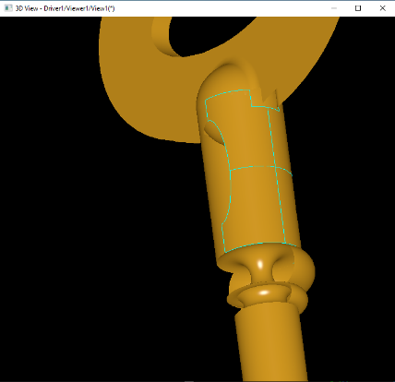 | 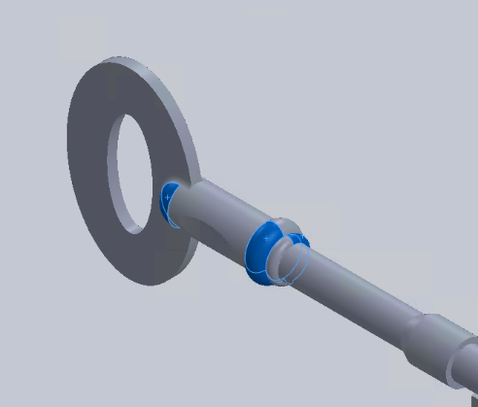 | 3106:#3570 = TOROIDAL_SURFACE('',3105:#3569,0.15,0.100285503404);  3142:#3615 = CURVE_BOUNDED_SURFACE('',3106:#3570,(5981:#3614),.F.);  5981:#3614 = OUTER_BOUNDARY_CURVE('',(5974:#3607,5976:#3609,5977:#3610,5978:#3611,5980:#3613),.F.);
test de step_1 E2
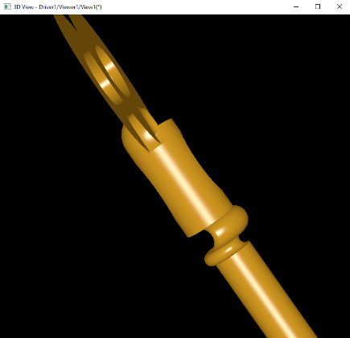 | 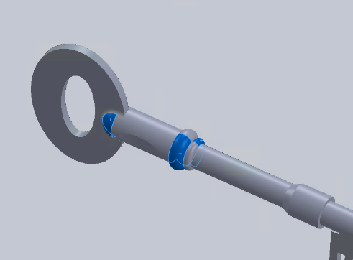 | 3110:#3574 = TOROIDAL_SURFACE('',3109:#3573,0.15,0.100285503404);  3146:#3619 = CURVE_BOUNDED_SURFACE('',3110:#3574,(5961:#3618),.F.);  5961:#3618 = OUTER_BOUNDARY_CURVE('',(5954:#3611,5956:#3613,5957:#3614,5958:#3615,5960:#3617),.F.);
test de step_1 G9
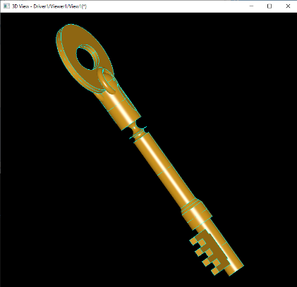 | 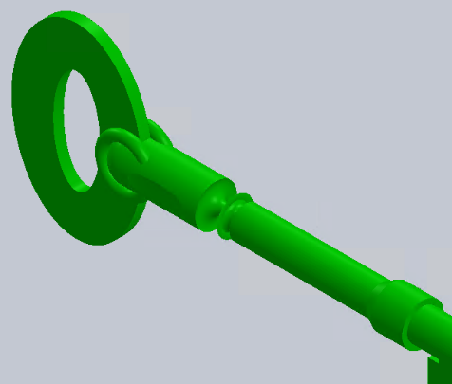 | #1717 = TOROIDAL_SURFACE('#1717',#1716,0.22912878475,5.E-02);  #1750 = BOUNDARY_CURVE('#1750',(#1725,#1733,#1741,#1749),.F.);  #1751 = CURVE_BOUNDED_SURFACE('#1751',#1717,(#1750),.F.);
test de step_2 B3
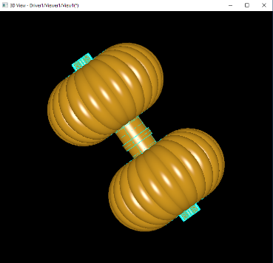 | 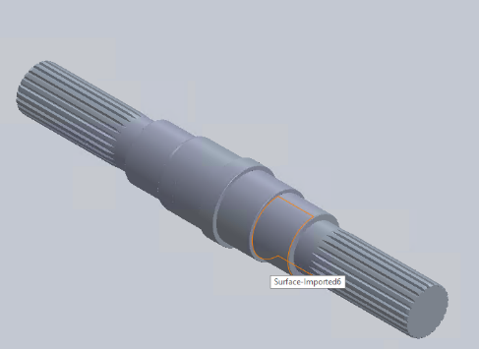 | 5147:#7074 = TOROIDAL_SURFACE('',5146:#7073,94.19517153949,34.2);  5148:#7080 = CURVE_BOUNDED_SURFACE('',5147:#7074,(9544:#7079),.F.);  9544:#7079 = OUTER_BOUNDARY_CURVE('',(9540:#7075,9541:#7076,9542:#7077,9543:#7078),.F.);
test de step_2 Q5
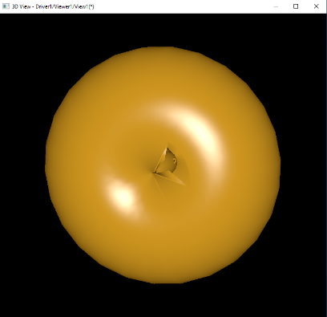 | 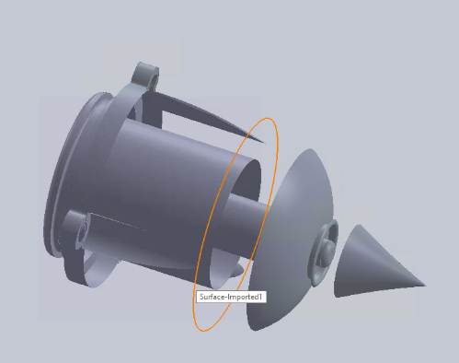 | #4355 = TOROIDAL_SURFACE('',#4356,0.130121241205,0.159999996424);  #5841 = ADVANCED_FACE('',(#5842),#4355,.F.);  #5842 = FACE_BOUND('',#5843,.F.);
test de step_2 Q6
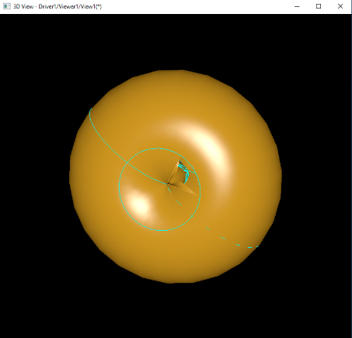 | 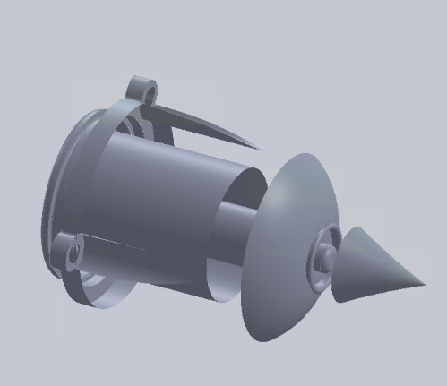 | #4355 = TOROIDAL_SURFACE('',#4356,0.130121241205,0.159999996424);  #5841 = ADVANCED_FACE('',(#5842),#4355,.F.);  #5842 = FACE_BOUND('',#5843,.F.);
test de step_3 B9
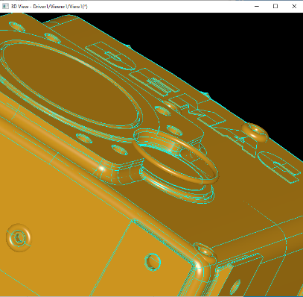 | 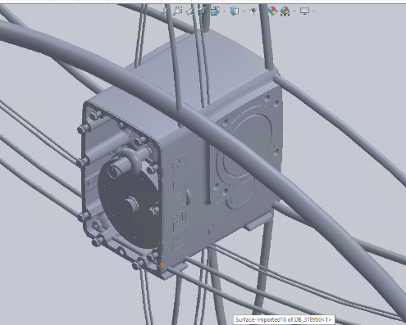 | 24957:#31197 = TOROIDAL_SURFACE('',24956:#31196,43.70917206496,2.5);  24958:#31205 = CURVE_BOUNDED_SURFACE('',24957:#31197,(78740:#31204),.F.);  78740:#31204 = OUTER_BOUNDARY_CURVE('',(78734:#31198,78735:#31199,78736:#31200,78737:#31201,78738:#31202,78739:#31203),.F.);
test de step_3 C8
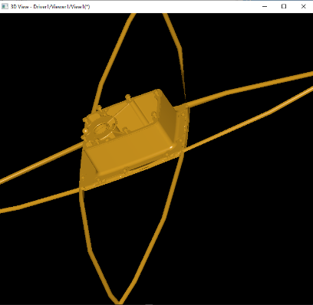 | 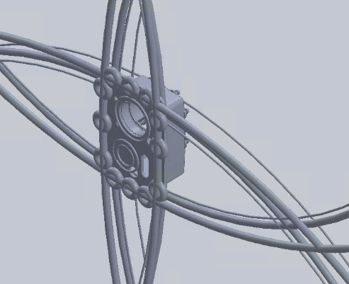 | 8638:#11006 = TOROIDAL_SURFACE('',8637:#11005,1.692841838119E+03,7.);  8639:#11020 = CURVE_BOUNDED_SURFACE('',8638:#11006,(23826:#11019),.F.);  23826:#11019 = OUTER_BOUNDARY_CURVE('',(23814:#11007,23815:#11008,  23816:#11009,23817:#11010,23818:#11011,23819:#11012,23820:#11013,  23821:#11014,23822:#11015,23823:#11016,23824:#11017,23825:#11018),.F.);
test de step_3 E4
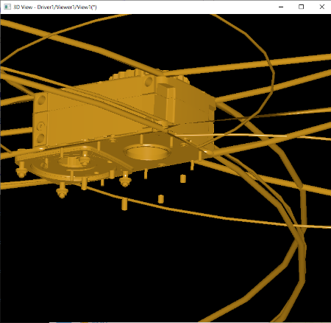 | 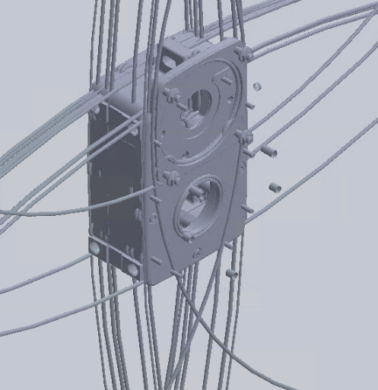 | 71086:#97513 = TOROIDAL_SURFACE('',71085:#97512,5.8,0.8);  71087:#97519 = CURVE_BOUNDED_SURFACE('',71086:#97513,(100792:#97518),.F.);  100792:#97518 = OUTER_BOUNDARY_CURVE('',(100788:#97514,100789:#97515,100790:#97516,100791:#97517),.F.);

