- modification: Mesh module->toolkit
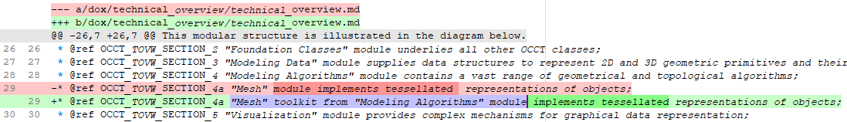
result is:
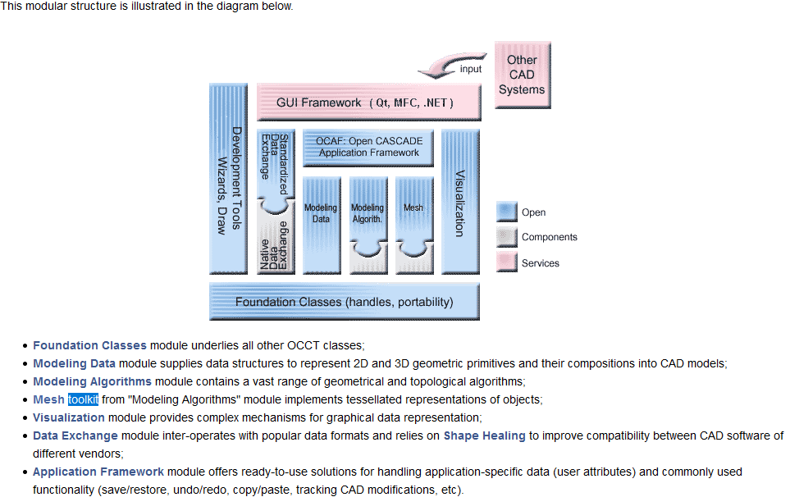
strange: 1. having toolkit and module on the same level in the list; 2. on the image toolkit has the same color/style/size as parent module.
proposal: mesh is moved to be a subitem of modeling algorithms module in the list(and navigation tree), remove or change style for the mesh element on image.
- It’s not clear what is the grammar base of the sentence (never find the verb):
The view facilities provided by OCCT range from low-level tools working with basic geometry and topology…
It’s too complex. Proposed way of change:
The view facilities provided by OCCT range are:
- low-level tools (…),
- high-level tools (…),
- other (possibility to extend using in custom application, presentations, parameters, …)
- The presentations can be customized to take the specificity of your application into account. – not readable at all.
Proposal: The user is free/welcome/able to write custom presentations for the application needs.
- STEP (AP203: Mechanical Design, this covers General 3D CAD; AP214: Automotive Design; AP242).
AP242 - not whole functionality is supported, isn’t it?
- modification:
Now, we have no CDL or WOK. Why the user need to read/think about them here? It’s seems the user needs to know whether it’s better to use OCCT containers instead of std containers or not, advantages of these containers (allocators, hashers), not history.

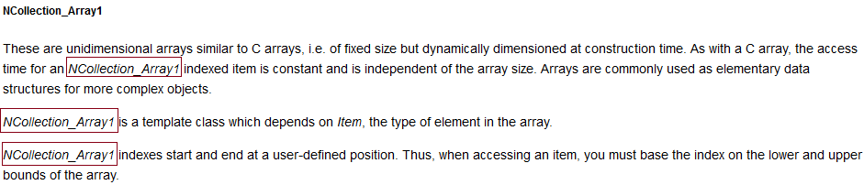
The caption tells which container is described. May we avoid repeating the array name again and again? The text is too short to forget it. The same for NCollection_Array2, NCollection_DataMap, NCollection_DoubleMap, NCollection_IndexedDataMap. Let’s use ‘this container’, ‘it’ instead of direct name?
- “NCollection provides several classes for storage of objects by value, providing fast search due to use of hash”: - may be let’s say: ”OCCT provides …” because in the list below we see that it is NCollection:
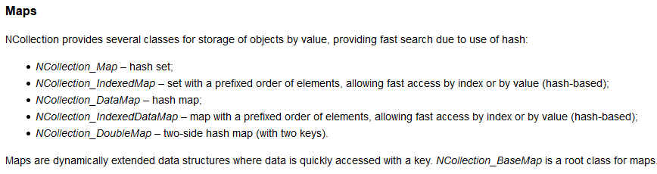
- “Map items may contain complex non-unitary data, thus it can be difficult to manage them with an array. The map allows a data structure to be indexed by complex data.” – too complex description. Firstly, may be it’s better to avoid using negative words like “difficult to manage”. Secondly, let’s simplify the sentence, the proposal is:
Maps serve to describe a combination key to value, where both, key and value are unitary/non-unitary data.
- Caption “Collection of maps” inside the “Maps” is not clear. I’m thinking before reading… NCollection or may be collection<maps>? Before it I read overview, properties, definitions, OK. After: collections… not clear. After, each map type descriptions, OK. Then I return to “Collections of map”. Start. “The Collections component…” component? It’s not toolkit, not module, component. What is it? Word “Collections” in this sentence starts from the upper letter, why?

Is this text a description why maps are placed in NCollection package?
Following the information in this text, the proposal is to move the information from “Collection of maps” into the “General properties of maps” without making a chapter.
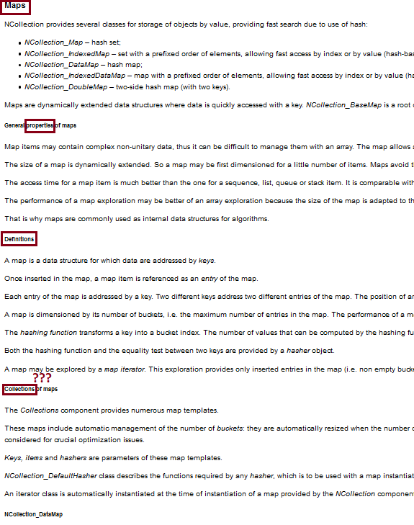
- Init, More, Next, Value are not very accented/visible/pointed here:
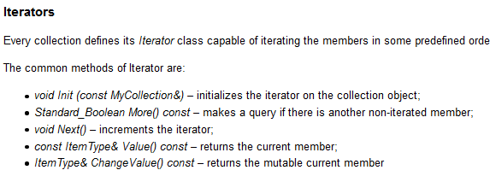
Proposals:
1. make the methods names bold (not very friendly but better than now),
2. smt like table
|Init | void Init(const…) | initializes …
|More | Standard_Boolean More() | makes …
|Next | void Next() | increments …
…
The goal is to point out that it’s simple to use iterators, short/clear words. Not aligned text as it’s now, makes the user think that as it’s hard to read then may be hard to use…
- Some packages might define a dedicated Iterator classes like “TColStd_MapIteratorOfMapOfInteger for TColStd_MapOfInteger::Iterator, which has been done for preserving an old API where Iterator classes have been instantiated independently. There is no reason to use these old aliases in new code.” – the better place to write it is CodingRules, this page is a documentation, why should the user read about some obsolete code? He wants to know about Iterator. The proposal is to remove this note here.
- BVH_Tree description is absent (link to outside description is also absent), but others have description:
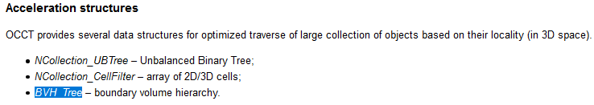
- What containers are mentioned below? Not precise text at all, not helpful, not meaningful. What is the purpose the user spent time on reading it?
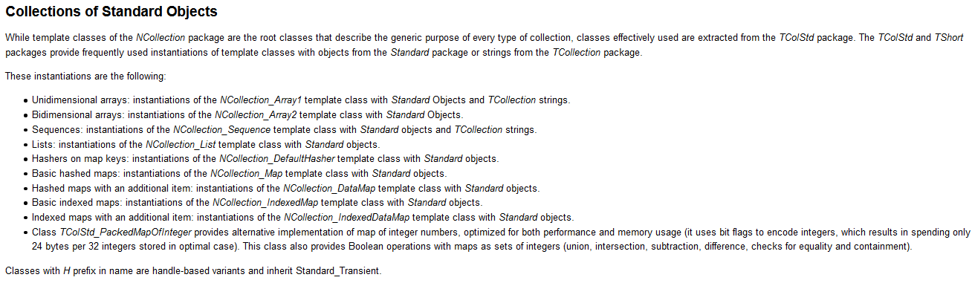
The proposal: replaced whole this text by:
Packages TShort/TColStd/TColgp/... have extension/typedef/rename/covering for collections over default OCCT types into named type.
The example is:
typedef NCollection_List<Handle(Standard_Transient)> TColStd_ListOfTransient;
or:
typedef NCollection_Sequence<gp_Pnt> TColgp_SequenceOfPnt;
Please, use them if you need a container for default OCCT type.
And… that’s enough here. Either, for each line, please give some example (some name of the class) to be more clear and useful.

