Dear Jerome Caucat,
My colleagues and I had discussions about your problem, and we have a question to you about possible solution.
Also, we would like to make some recommendations to you about the input data for the algorithm.
1. Monitoring correctness of the input data.
The algorithm's requirements to the input data are soft. This means that the end user must always monitor the correctness of the input data in terms of its effect on the desired result.
For example, you can put into the algorithm the next parameter set (Pic. 1):
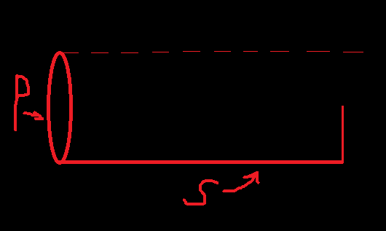
Pic. 1 – The parameter set
In this case, you will also receive the result with “cross”, just like in your “sample_cross_6” (Pic. 2).
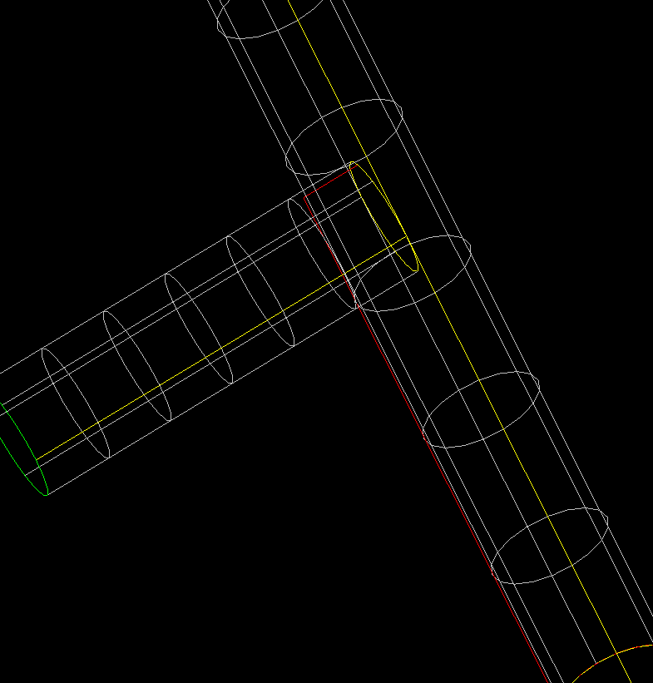
Pic. 2 – The result of sweep algorithm
In your case, the length of the edge(E) (the part of the spine) smaller than the width of the resulting shape`s “end” (W) (Pic .3).
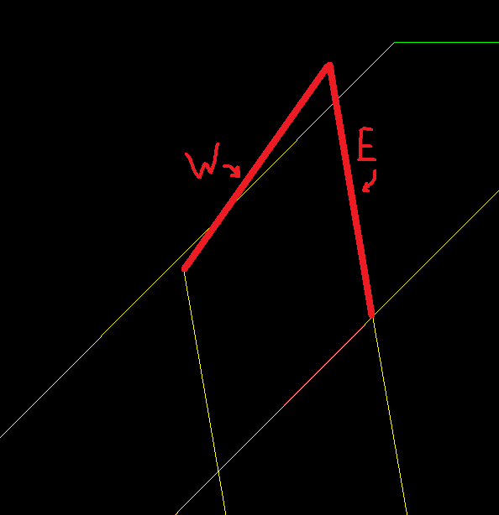
Pic. 3 – “sample_cross_6”
In this situation, we offer to you to change your input parameters, because there is no possible solution to fix the result by changing internal structure of the sweep-algorithm.
Given requirement for edge length applies not only for the edges on start/end of the spine, but for the edges in the middle of this spine (Pic. 4). The current set of parameters also leads to the result with “cross” (Pic.5).
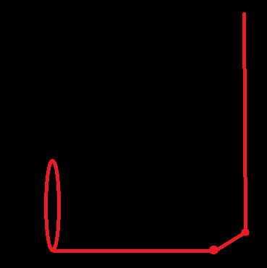 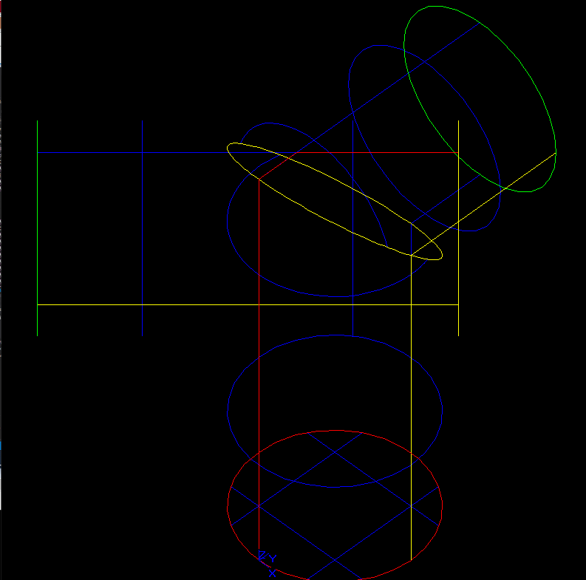
Pic. 4 – The small edge in the middle of the Pic. 5 – Result of the sweep
spine

2. A common solution to the "cross" case - combining neighboring edges
The initial problem of this bug also arises because of the difference between widths of the edges in the spine and the profile. You can see it on Pic.6:
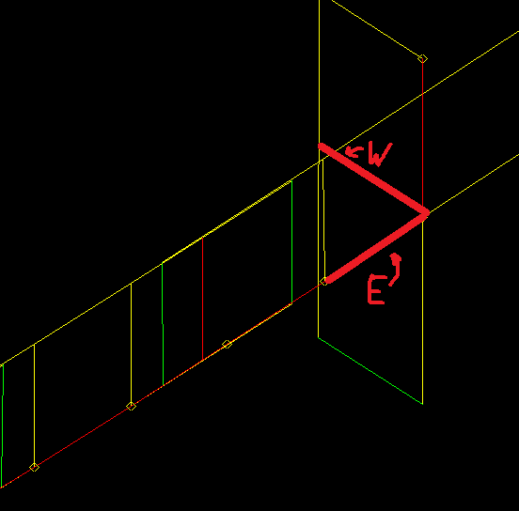
Pic. 6 – “sample_cross_4”

In case of situation on Pic.6 (and the same analogical) we can offer to you a solution: merge edges, that smoothly connect to each other. This solution will allow avoiding current situation with the differences of widths. Below are examples of the use of this method by-hands (Pic.7 and Pic.8)
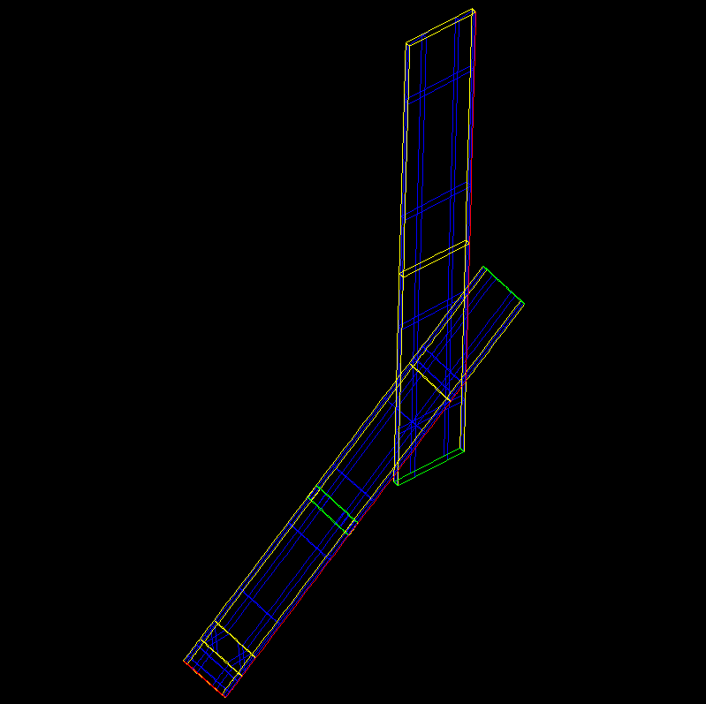 | 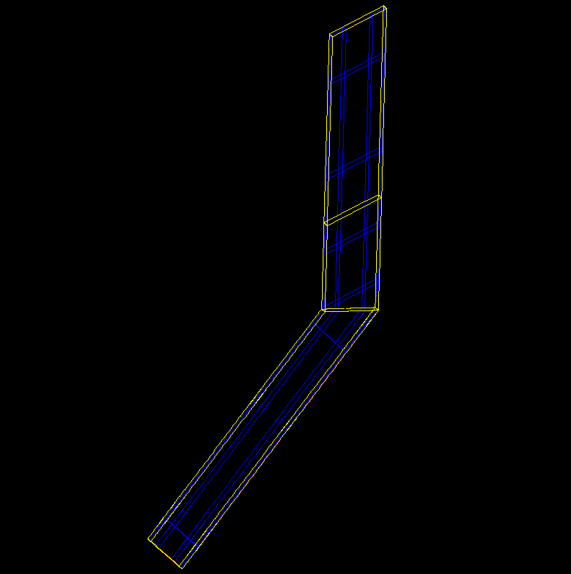
Pic. 7 – Model without merging Pic. 8 – Model with merging
But current method changes the number of sub-shapes of the model. Because of this, we need to know, does it matter to you the number of sub-shapes in the resulting shape?
For example, if you are trying to build tube with spine containing N edges and from the profile containing M edges, then you will get resulting shape with N*M+2 faces, where 2 – faces on the end of tube. But after merging – (N-L) *M+2, where L – the number of combined edges of the spine.

3. Recommendations for the input data of the algorithm.
Consider the behavior of the algorithm with the different parameters on the “sample_cross_6” (Pic. 9 and Pic.10)
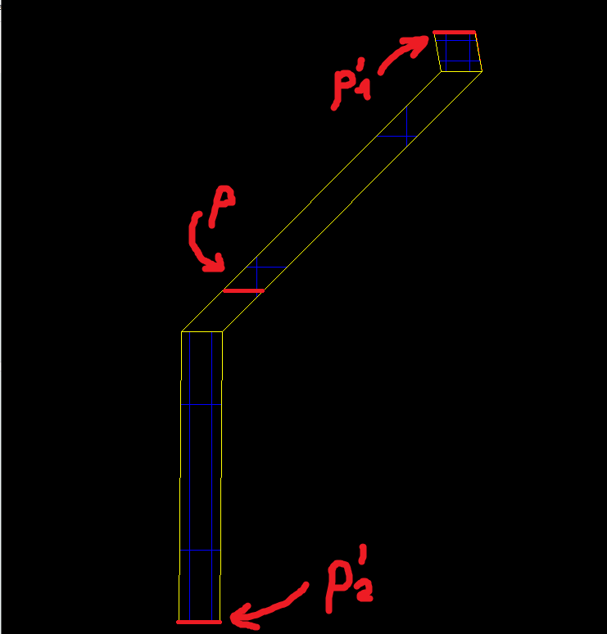 | 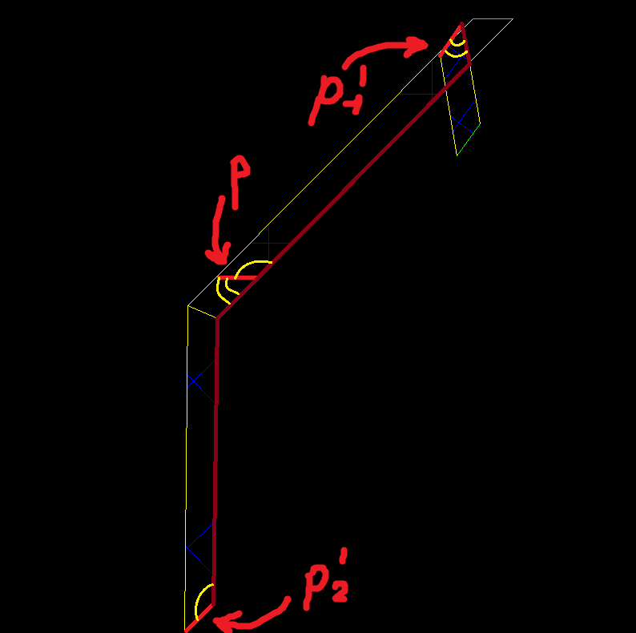

Pic. 9 – with parameter by default Pic. 10 – with parameter “-C”
When the transition mode is set the default parameter for “buildsweep” command, the closing wires are built by transferring the original wire (P) without changing it (to p₁’ and p₂’) which leads to changing the width of the resulting shape. In case of setting “-C” or “-R” parameter, this wire also rotated avoid changing width. This rotate is the cause of the creation resulting shape with “cross”.

The main recommendations for the input data:
- Lack of the smooth connections between neighboring edges of the spine
- Lack of the small edges in the spine
- The profile is the orthogonal to the path (especially, in case of using “-R” parameter)
- It is desirable to place the profiles at the ends of the path, for a more specific understanding of how the resulting shape should look like

P.S. We suggest the modification of the input data according to the above recommendations. Otherwise, the probability of occurrence of a case with “cross” increases.

4. Solutions for samples
sample_cross_1 | Change input data (the edge is too small)
sample_cross_2 | Change input data (the edge is too small)
sample_cross_3 | Merge small edges with smooth connections to one / use another set of parameters
sample_cross_4 | Merge small edges with smooth connections to one
sample_cross_5 | Change input data (the edge is too small)
sample_cross_6 | Change input data (the edge is too small)

